LECTURE 7
RAID

RAID
Definition
- RAID stands for Redundant Array of Independent Disks (originally “Inexpensive” Disks).
- It is a storage technology that combines multiple physical disks into a single logical storage unit.
Purpose
RAID is designed to:
- Improve data reliability
- Improve system performance
- Increase storage capacity
Why RAID Is Important
- A single hard disk is a single point of failure.
- If that disk fails, all stored data may be lost.
- RAID reduces this risk by distributing or duplicating data across multiple disks.
Where RAID Is Used
- Servers
- Data centers
- Enterprise storage systems
- Network Attached Storage (NAS)
- High-performance computing systems

RAID Expanded Definition & Classification)
Types of RAID Systems
There are two main types:
1. Hardware RAID
- Uses a dedicated RAID controller card.
- The controller contains built-in software to manage:
  - Disk setup
  - Input/Output (I/O) operations
  - RAID configuration
- RAID operations are handled independently of the operating system.
Advantages:
- Better performance
- Reduces CPU load on the main system
- More reliable for enterprise environments
Disadvantages:
- Expensive
- Requires dedicated hardware
2. Software RAID
- No physical RAID controller is used.
- The operating system manages RAID configuration.
- RAID processing is handled by the system CPU.
Advantages:
- Cost-effective
- Easy to implement
- Suitable for small systems
Disadvantages:
- Uses system resources
- May reduce overall system performance

Types
Hardware RAID – Detailed Operation
- Disks connect to a RAID controller.
- Controller manages:
  - Disk communication
  - Error handling
  - Parity calculations
  - Data distribution
- Appears to the operating system as a single logical drive.
Key Characteristic:
- RAID management is independent of OS failure.
Software RAID – Detailed Operation
- Managed by the operating system.
- Logical array is created via OS configuration.
- RAID level is controlled by system software.
Key Characteristic:
- RAID functionality depends on the operating system.
- If the OS fails, RAID access may be affected.

RAID (Basic Idea & Functional Goals)
Fundamental Concept
Connect multiple disks together to achieve:
1. Large Storage Capacity
- Multiple disks combine to form one large logical storage space.
2. Faster Data Access
- Data can be read or written in parallel across multiple disks.
- Parallel operations improve speed.
3. Redundant Data
- Data may be duplicated or protected with parity.
- Provides fault tolerance.
How RAID Achieves These Goals
Depending on configuration:
- Performance Increase
  - Reading/writing happens in parallel.
  - Data blocks are distributed across disks.
- Reliability Increase
  - Data duplication (mirroring)
  - Parity-based error checking
Some RAID levels focus on:
- Performance (e.g., RAID 0)
- Reliability (e.g., RAID 1)
- Balanced performance and reliability (e.g., RAID 5, RAID 6)
Important Trade-Off Factors Mentioned
RAID levels differ in:
- Redundancy level
- Error checking method
- Storage efficiency
- Performance
- Cost
This introduces the idea that:
Not all RAID configurations provide both high performance and high reliability at the same time.

Striping
Definition
Striping is a RAID technique where file data is divided into blocks and distributed across multiple disks in an array.
How Striping Works
- A file is broken into equal-sized blocks.
- Each block is written to a different disk in sequence.
Example:
- Block 0 → Disk 0
- Block 1 → Disk 1
- Block 2 → Disk 2
- Block 3 → Disk 3
This process continues in rotation.
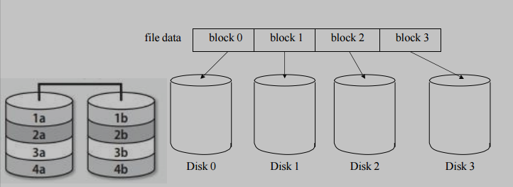
Purpose of Striping
1. Improves Performance
- Multiple disks can be accessed simultaneously.
- Enables parallel reading and writing.
- Increases data throughput.
2. Better Bandwidth Utilization
- Workload is distributed across disks.
- Reduces single-disk bottlenecks.
Advantages
- Very fast read performance.
- Very fast write performance.
- Efficient use of total disk capacity.
Disadvantages
- No redundancy by itself.
- If one disk fails, all data in the array is lost.
- Reliability decreases as more disks are added.
Where Striping Is Used
- RAID 0
- Part of RAID 10
- Used in high-performance systems where speed is more important than data protection.

Parity
Definition
Parity is a method of error detection and data recovery used in RAID systems.
It allows reconstruction of lost data if one disk fails.
Basic Parity Concept
Parity works by:
- Counting the number of bits with value 1.
- Setting a parity bit:
  - Even number of 1s → parity bit = 0
  - Odd number of 1s → parity bit = 1
In RAID, parity is calculated using the XOR (exclusive OR) operation.
Why XOR Is Used
XOR has a special property:
If:
A ⊕ B ⊕ C = P
Then:
If A is lost →
A = B ⊕ C ⊕ P
This allows reconstruction of missing data.
Purpose of Parity in RAID
1. Fault Tolerance
- If one disk fails, lost data can be recalculated using parity information.
2. Storage Efficiency
- Uses less storage than mirroring.
- Only one disk (or equivalent space) is used for parity.
Advantages
- Provides redundancy without duplicating all data.
- More storage-efficient than RAID 1.
Disadvantages
- Parity calculations add overhead.
- Write operations are slower because parity must be updated.
- Can only recover from limited disk failures (usually one disk in RAID 5).
Where Parity Is Used
- RAID 3
- RAID 4
- RAID 5
- RAID 6 (uses double parity)

Mirroring
Definition
Mirroring is a RAID technique where identical copies of data are stored on two separate disks.
Each disk contains the exact same data.
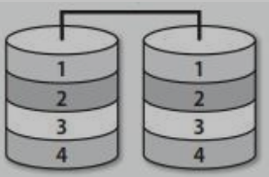
How Mirroring Works
- When data is written:
  - It is written to Disk 1.
  - The same data is simultaneously written to Disk 2.
- When reading:
  - Data can be read from either disk.
Purpose of Mirroring
1. Data Redundancy
- If one disk fails, the other disk contains a complete copy.
- No data reconstruction is required.
2. Improved Read Performance
- System can read different parts of data from both disks simultaneously.
- Load balancing improves performance.
Advantages
- Very high reliability.
- Simple recovery process.
- Fast read performance.
- No complex parity calculations.
Disadvantages
- Expensive.
- Requires twice as many disks.
- Storage efficiency is only 50%.
- Write performance may be slightly slower (data written twice).
Where Mirroring Is Used
- RAID 1
- RAID 10 (combined with striping)

RAID Level-0 (Striping)
Definition
RAID Level-0 is the simplest RAID configuration and is often called striping.
It uses block-level striping across two or more disks.
How RAID 0 Works
- A file is divided into equal-sized blocks.
- Blocks are written across disks in alternating sequence.
Example (2 disks):
- Block 0 → Disk 0
- Block 1 → Disk 1
- Block 2 → Disk 0
- Block 3 → Disk 1
This continues in rotation.
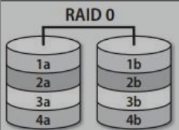
Key Characteristics
- Minimum disks required: 2
- No parity
- No mirroring
- No redundancy
RAID 0 focuses entirely on performance and capacity, not reliability.
Performance
Read Performance
- Very high.
- Multiple disks read data simultaneously.
- Improves throughput significantly.
Write Performance
- Also very high.
- Data is written in parallel across disks.
Storage Efficiency
- 100% of total disk capacity is usable.
- If two 1TB disks are used → total usable space = 2TB.
Major Disadvantage
No Fault Tolerance
- If one disk fails, all data in the array is lost.
- Failure probability increases as more disks are added.
RAID 0 increases speed but decreases reliability.
Typical Use Cases
- Gaming systems
- Video editing (temporary projects)
- High-speed cache storage
- Situations where data loss is acceptable or backed up elsewhere

RAID Level-0 (Illustration & Data Distribution)
This visually explains how RAID 0 distributes blocks across disks.

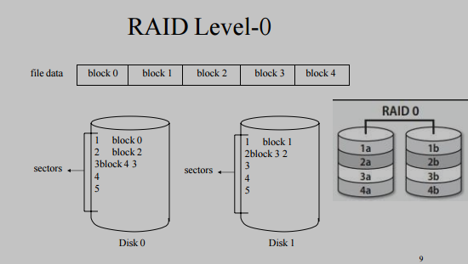
Block Distribution Example
Given file blocks:
block 0 | block 1 | block 2 | block 3 | block 4
With 2 disks:
Disk 0 stores:
- block 0
- block 2
- block 4
Disk 1 stores:
- block 1
- block 3
This alternating pattern ensures balanced load distribution.
Sector-Level View
The diagram shows how:
- Each disk stores non-contiguous pieces of the file.
- Blocks are written in different sectors on each disk.
- Logical file appears continuous to the operating system.
Important Technical Insight
RAID 0 does not duplicate data.
Each disk contains unique portions of the file.
Therefore:
- Losing Disk 0 → blocks 0, 2, 4 are lost.
- Losing Disk 1 → blocks 1, 3 are lost.
- Missing even one block makes the entire file unusable.
Why RAID 0 Is Fast
- Parallel I/O operations
- Reduced seek time per disk
- Increased data bandwidth
- Load balancing across disks
Risk Factor
Reliability formula concept:
If each disk has probability of failure P,
RAID 0 failure probability increases with number of disks.
More disks = higher risk.
Advantages and Disadvantages
• Fast access
• If one disk fails, the entire system will no more be able to use the data on all the disks

RAID Level-1 (Data Mirroring)
Definition
RAID Level-1 is a RAID configuration that uses data mirroring, where identical copies of data are stored on two separate disks.
Each disk contains a complete and exact copy of all data.
How RAID 1 Works
- A complete file is written to Disk 0.
- The same file is simultaneously written to Disk 1.
- Both disks always contain identical information.
This means:
- Disk 0 = Full copy
- Disk 1 = Full copy
Minimum Disk Requirement
- Requires at least 2 disks.
- Can be implemented with more disks in some enterprise setups (multiple mirrors).
Redundancy Level
RAID 1 provides complete redundancy:
- If one disk fails, the system continues operating using the remaining disk.
- No data reconstruction is required (unlike parity-based RAID).
Storage Efficiency
- Only 50% of total disk capacity is usable.
- Example:
  - 2 × 1TB disks → usable space = 1TB
  - 2 × 500GB disks → usable space = 500GB
This makes RAID 1 one of the most expensive RAID implementations per usable GB.
Reliability
RAID 1 offers:
- High fault tolerance
- Protection against single disk failure
- Fast recovery (simply replace failed disk and rebuild mirror)

RAID Level-1 (Illustration & Data Layout)
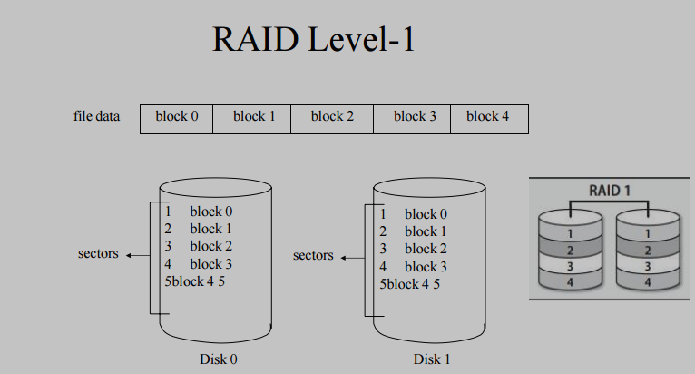
Data Distribution
Given file blocks:
block 0 | block 1 | block 2 | block 3 | block 4
Both disks store:
Disk 0:
- block 0
- block 1
- block 2
- block 3
- block 4
Disk 1:
- block 0
- block 1
- block 2
- block 3
- block 4
There is no striping and no parity.
Each disk is a full replica.
What Happens During Disk Failure
If:
- Disk 0 fails → Disk 1 continues functioning normally.
- Disk 1 fails → Disk 0 continues functioning normally.
The system does not lose data.
After replacing the failed disk:
- Data from the working disk is copied to the new disk.
- This process is called rebuilding the mirror.
Key Difference from RAID 0
RAID 0 | RAID 1
Data split across disks | Data duplicated
No redundancy | Full redundancy
100% capacity usable | 50% capacity usable
Very high risk | High reliability

RAID 1 Performance
Read Performance
RAID 1 improves read performance because:
- The system can read from either disk.
- Different read requests can be handled simultaneously.
- Load balancing is possible.
In multi-user systems:
- Disk 0 may serve one request.
- Disk 1 may serve another request.
This improves overall read throughput.
Write Performance
Write performance:
- Data must be written to both disks.
- Write speed is similar to a single disk (not doubled).
- Slight overhead exists because two write operations occur.
However:
- There is no parity calculation (unlike RAID 5 or 6).
- Therefore, write penalty is minimal compared to parity-based RAID.

RAID Level-10
Definition
RAID Level-10 (also written as RAID 1+0) is a RAID configuration that combines RAID 0 (Striping) and RAID 1 (Mirroring).
It provides both:
- High performance (from striping)
- High redundancy (from mirroring)
How RAID 10 Works
RAID 10 follows a two-step structure:
Step 1: Mirroring (RAID 1)
- Disks are grouped into mirrored pairs.
- Each disk has an identical copy in its mirror partner.
Step 2: Striping (RAID 0)
- Data is striped across these mirrored pairs.
- Blocks are distributed between the mirror groups.
So the system:
- First mirrors
- Then stripes across mirrored sets
Minimum Disk Requirement
- Requires at least 4 disks
  - 2 disks per mirror set
  - At least 2 mirror sets to stripe across
Performance Characteristics
Read Performance
- Very high.
- Multiple disks can serve read requests.
- Combines read benefits of RAID 0 and RAID 1.
Write Performance
- High performance due to striping.
- No parity calculations required.
- Faster than RAID 5 and RAID 6 for write-heavy workloads.
Redundancy & Fault Tolerance
- Can tolerate multiple disk failures, as long as:
  - Both disks in the same mirrored pair do not fail.
Example (4 disks):
- Disk 1 fails → OK
- Disk 3 fails → OK
- But if Disk 1 and its mirror fail → Data loss
Storage Efficiency
- 50% usable storage (same as RAID 1).
Example:
- 4 × 1TB disks → usable space = 2TB
- 6 × 2TB disks → usable space = 6TB
Half of total storage is used for redundancy.
Cost
- Considered the most expensive RAID configuration.
- Requires double the storage for redundancy.
- But provides best balance of performance and reliability.
RAID 10 (Diagram Explanation)
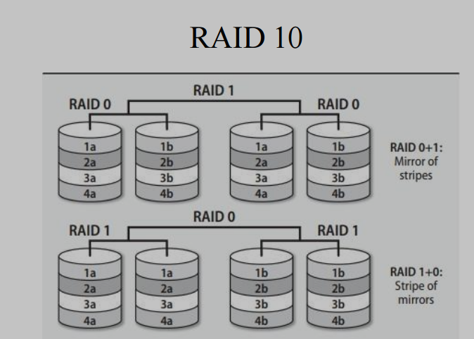

Understanding the Diagram
Two possible conceptual views are shown:
RAID 0+1 (Mirror of Stripes)
- Data is first striped.
- Then the striped sets are mirrored.
- Less fault tolerant than RAID 1+0.
RAID 1+0 (Stripe of Mirrors) – True RAID 10
- Disks are first mirrored.
- Then data is striped across mirrored sets.
- More fault tolerant.
- This is the standard RAID 10 implementation.
RAID 0+1 vs RAID 1+0 (Important Distinction)
RAID 0+1 | RAID 1+0
Mirror of stripes | Stripe of mirrors
Less fault tolerant | More fault tolerant
Entire stripe group may fail | Only affected mirror pair fails
Rarely used today | Common enterprise solution
RAID 10 refers specifically to RAID 1+0, not RAID 0+1.
Why RAID 10 Is High Performance
- No parity calculations
- Parallel read/write operations
- Reduced rebuild stress compared to RAID 5
- Fast recovery (mirror rebuild only)
Where RAID 10 Is Used
- Database servers
- High-transaction systems
- Virtual machines
- Enterprise applications
- Systems requiring both speed and reliability

RAID 2 (Bit-Level Striping with Dedicated Hamming Code Parity)
Definition
RAID 2 uses:
- Bit-level striping
- Dedicated error correction using Hamming Code
- Separate disks to store error-correcting information
How RAID 2 Works
- Data is split at the bit level (not block or byte).
- Each bit is written to a different disk.
- Additional disks store Hamming Code parity for error correction.
Example:
- Disk 1 → Bit 1
- Disk 2 → Bit 2
- Disk 3 → Bit 3
- Extra disks → Error correction codes
Key Characteristics
- Requires multiple disks for both data and error correction.
- Uses complex Hamming Code instead of simple XOR parity.
- Can detect and correct errors automatically.
Why RAID 2 Is Rarely Used
- Modern disks already have built-in error correction.
- Requires high synchronization between disks.
- Very expensive and complex.
- Inefficient compared to RAID 5 and RAID 6.
As a result:
RAID 2 is considered obsolete in modern systems.

RAID 3 (Byte-Level Striping with Dedicated Parity)
Definition
RAID 3 uses:
- Byte-level striping
- One dedicated parity disk
Unlike RAID 5:
- Parity is stored on a single separate disk.
- Parity is not distributed across all disks.

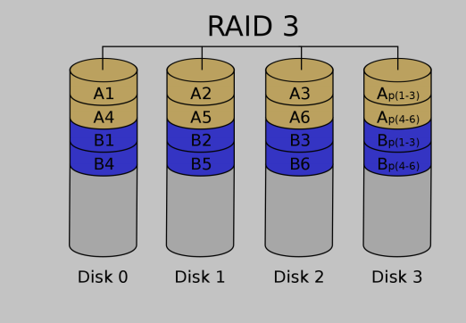
How RAID 3 Works (According to the Diagram)
In the image, there are 4 disks:
- Disk 0
- Disk 1
- Disk 2
- Disk 3 (Parity Disk)
Data Distribution
Look at the first row in the diagram:
- Disk 0 → A1
- Disk 1 → A2
- Disk 2 → A3
- Disk 3 → Ap(1–3)
This means:
- A1, A2, A3 are pieces of the same data stripe.
- Ap(1–3) is the parity calculated from A1, A2, and A3.
Parity is calculated using XOR:
Ap(1–3) = A1 ⊕ A2 ⊕ A3
Next Stripe
Second row:
- Disk 0 → A4
- Disk 1 → A5
- Disk 2 → A6
- Disk 3 → Ap(4–6)
Again:
- A4, A5, A6 are split across the three data disks.
- Parity for them is stored on Disk 3.
Same Pattern Continues (Group B)
For B data:
- Disk 0 → B1
- Disk 1 → B2
- Disk 2 → B3
- Disk 3 → Bp(1–3)
And then:
- Disk 0 → B4
- Disk 1 → B5
- Disk 2 → B6
- Disk 3 → Bp(4–6)
Each row represents one stripe group.
What Happens If a Disk Fails?
Suppose Disk 1 fails (A2, A5, B2, B5 lost).
To recover A2:
A2 = A1 ⊕ A3 ⊕ Ap(1–3)
The system uses:
- Remaining data disks
- Parity disk
to reconstruct the missing data.
Minimum Disk Requirement
- At least 3 disks
  - 2 data disks
  - 1 parity disk
Performance Characteristics
Sequential Access Performance
- Very good.
- All disks work together to read/write large continuous data.
- Ideal for large file transfers.
Small or Random Access Performance
- Poor.
- Every I/O operation must involve all disks.
- Parity disk becomes a bottleneck.
Disadvantages
- Dedicated parity disk causes write bottleneck.
- Not efficient for multiple small requests.
- Not suitable for multi-user environments.
- Largely replaced by RAID 5.
Fault Tolerance
- Can survive failure of one disk.
- If parity disk fails, system still functions but without redundancy until replaced.

RAID 4 (Block Level Striping with Dedicated Parity)
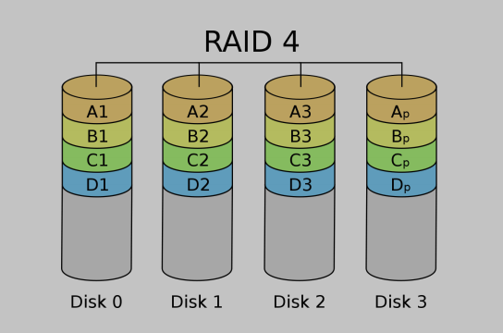
How It Works (Based on the Diagram)
In the screenshot, there are four disks:
- Disk 0
- Disk 1
- Disk 2
- Disk 3 (Parity Disk)
1. Block-Level Striping
RAID 4 divides data into full blocks (not bytes).
From the diagram:
First stripe:
- Disk 0 → A1
- Disk 1 → A2
- Disk 2 → A3
- Disk 3 → Ap
Here:
- A1, A2, A3 are complete data blocks.
- Ap is the parity block calculated from A1, A2, and A3.
Parity formula:
Ap = A1 ⊕ A2 ⊕ A3
Second stripe:
- Disk 0 → B1
- Disk 1 → B2
- Disk 2 → B3
- Disk 3 → Bp
Bp = B1 ⊕ B2 ⊕ B3
The same pattern continues for C and D blocks.
Each row represents one block stripe group.
2. Dedicated Parity Disk
Disk 3 stores only parity blocks:
- Ap
- Bp
- Cp
- Dp
All parity information is centralized on this single disk.
3. Data Recovery
If Disk 1 fails (A2, B2, C2, D2 lost):
Example recovery:
A2 = A1 ⊕ A3 ⊕ Ap
The system uses:
- Remaining data blocks
- Parity block
RAID 4 can tolerate one disk failure.
4. Performance Characteristics
Read Performance:
- Good for small reads.
- Since striping is at block level, a single block can be read from one disk.
Write Performance:
- Slower than expected.
- Every write must update:
  - The data block
  - The parity block on Disk 3
This makes Disk 3 a bottleneck.

RAID 5 (Block Level Striping with Distributed Parity)
Definition
RAID 5 uses:
- Block-level striping
- Distributed parity
It stripes both data and parity information, adds redundancy, and improves read performance while maintaining good storage efficiency.
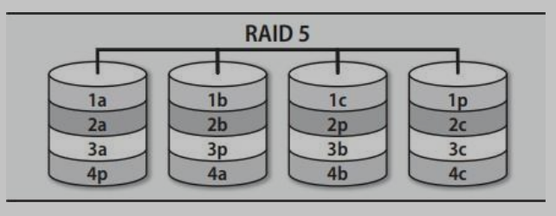
How RAID 5 Works
1. Block-Level Striping
File data is divided into blocks and distributed across all disks in the array.
Example (4 disks):
Stripe 1:
- Disk 0 → A1
- Disk 1 → A2
- Disk 2 → A3
- Disk 3 → Ap (parity)
Stripe 2:
- Disk 0 → B1
- Disk 1 → B2
- Disk 2 → Bp (parity)
- Disk 3 → B3
Stripe 3:
- Disk 0 → C1
- Disk 1 → Cp (parity)
- Disk 2 → C2
- Disk 3 → C3
Parity blocks rotate across disks.
There is no single dedicated parity disk.
No Single Check Disk
It is stated that:
- There is no longer a single check disk.
- There is no write bottleneck caused by one parity disk.
Since parity is distributed, write operations can occur in parallel across disks.
Fault Tolerance
- Provides fault tolerance using parity.
- Data and parity information are distributed over all disks.
- If one disk fails, data can be reconstructed.
Example:
If A2 is lost:
A2 = A1 ⊕ A3 ⊕ Ap
RAID 5 can tolerate failure of one disk only.
Storage Efficiency
If there are N drives in the array (minimum 3 required):
Usable storage = N − 1 drives
Examples:
- 3 drives → 2 drives usable
- 4 drives → 3 drives usable
Space efficiency is at least 67%, which is higher than mirroring (maximum 50%).
Performance
- Radically improves performance of multiple writes because writes can be done in parallel.
- Slightly improves read performance because there is one more disk available for reading.
- Write performance is slower than RAID 0 and RAID 10 due to parity calculations, but better than RAID 4 because parity is distributed.

RAID 6 (Block Level Striping with Double Distributed Parity)
Definition
RAID 6 is similar to RAID 5 but uses two parity blocks per stripe instead of one.
It provides:
- Block-level striping
- Double distributed parity
- Higher fault tolerance than RAID 5
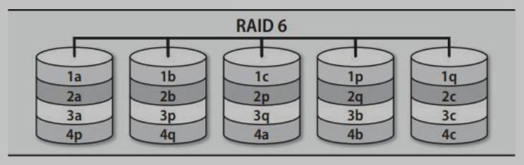
How RAID 6 Works
1. Block-Level Striping
Data is divided into blocks and distributed across disks, just like RAID 5.
Example (5 disks):
Stripe 1:
- Disk 0 → 1a
- Disk 1 → 1b
- Disk 2 → 1c
- Disk 3 → 1p (Parity 1)
- Disk 4 → 1q (Parity 2)
Stripe 2:
- Disk 0 → 2a
- Disk 1 → 2b
- Disk 2 → 2p
- Disk 3 → 2q
- Disk 4 → 2c
Parity blocks rotate across disks, meaning no single disk is dedicated only to parity.
2. Double Distributed Parity
Each stripe has:
- Two independent parity calculations (often called P and Q).
This means:
Parity 1 = XOR-based parity
Parity 2 = Second independent parity calculation
Because there are two parity values, the system can recover from two disk failures.
3. Fault Tolerance
RAID 6 can withstand:
- Complete failure of two drives without losing data.
If:
- One disk fails → Data rebuilt using parity.
- Two disks fail → Data still rebuilt using double parity.
If three disks fail → Data loss occurs.
4. Minimum Disk Requirement
- Requires at least 4 disks.
5. Storage Efficiency
If there are N disks:
Usable storage = N − 2 disks
Example:
- 4 disks → 2 usable
- 5 disks → 3 usable
- 6 disks → 4 usable
Storage efficiency is lower than RAID 5 but higher than RAID 1 for larger arrays.
6. Performance Characteristics
Read Performance:
- Good.
- Similar to RAID 5.
Write Performance:
- Slower than RAID 5.
- Two parity calculations must be performed.
- Higher write penalty.

